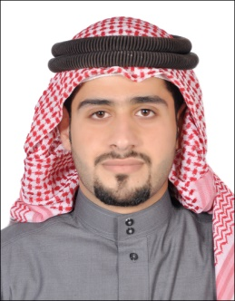**Personal Information**

**Name: Abdulhaleem Saleh Khalaf Alrawajfeh.**

**Date of birth: 5/3/1995**

**Material Status: Single**

**Gender: Male**

**Occupation: Student**

**Nationality: Bahraini**

**Address: East Riffa / Block : 913 - Road N0 : 1325 – Bulding No : 1499 – Flat No: 11**

**Phone Number : 39332287 – 33609839**

**E-mail address:** a.haleem3452@gmail.com

**Qualification**

* **Graduated on june 2013 from Alriffa Secondary School**
* **I worked as a volunteer at Sharifa Al Awadi Center for Youth**
* **I graduated from the University of Bahrain with a Bachelor of Law degree 2.56**

**Skills**

* **Excellent in practical work**
* **Ability to work effectively as a member of team**
* **Ability to concentrate at work accurately under pressure**
* **Ability to use hand tools**
* **Excellent in Microsoft office**
* **Excellent in using Pc**
* **organizarional skills**
* **ably to give and take instruction**

**Language**

* **Arabic (Native)**
* **English**

**Objective**

* **My objective is to develop myself into a successful life.**
* **Developing my company and my own work.**